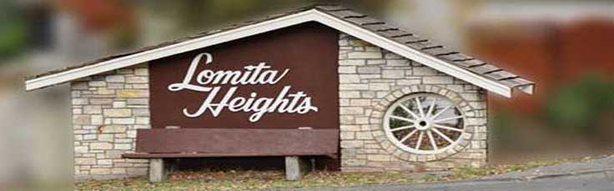


LOMITA HEIGHTS NEIGHBORHOOD ASSOCIATION

BRING A DISH TO SHARE, BEVERAGES, PLATES, UTENSILS AND TABLES WITH CHAIRS

SUNDAY, AUGUST 27, 2017
4:30 pm to 6:00 pm

TERRA LINDA CT.

